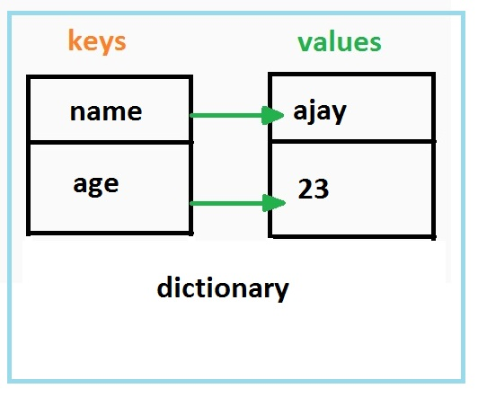
Python Dictionaries

A dictionary is a data type similar to arrays (or lists), but works by giving each value in a collection a name (or KEY) instead of giving it a numerical addresses or index.
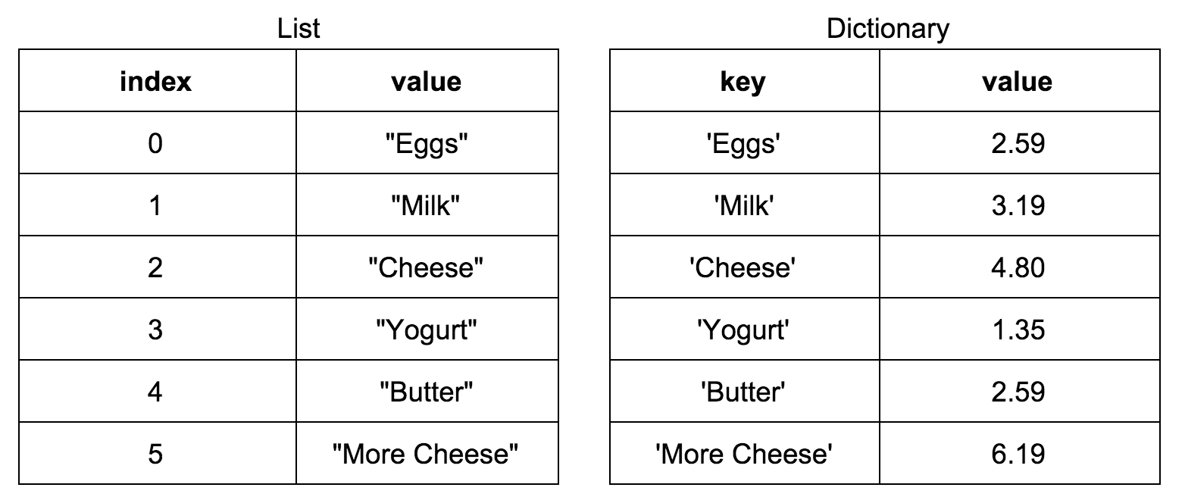

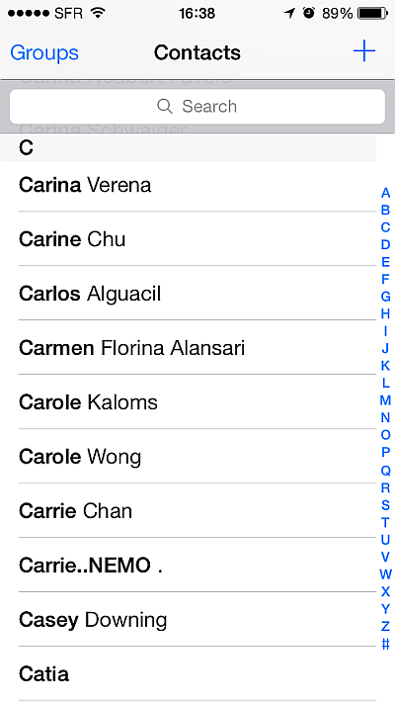
A contact list is a good example of the necessity and usefulness of dictionaries. Sometimes we want to label data with a word or name rather than just a location. If we want to look up someone’s phone number in out contact list we would get their number by looking up name rather than looking up anything related to their actual phone#

The name in this case is called the KEY in our dictionary

A dictionary could consist of names with phone numbers:

>>> phoneNumbers[“Mary”] = “555-6789”
>>> phoneNumbers[“Bob”] = “444-4321”
>>> phoneNumbers[“Jenny”] = “867-5309”

or alternatively we could initialize the dictionary like this:

>>> phoneNumbers = {'Bob': '444-4321', 'Mary': '555-6789', 'Jenny': '867-5309'}

>>> print phoneNumbers
{'Bob': '444-4321', 'John': '555-1234', 'Mary': '555-6789', 'Jenny': '867-5309'}
>>> phoneNumbers = {'Bob': '444-4321', 'Mary': '555-6789', 'Jenny': '867-5309'}

And dictionaries have some methods that we can use to work with them.

- The keys method gives us a list of all the dictionary keys:

>>> phoneNumbers.keys()
['Bob', 'John', 'Mary', 'Jenny']

- The values method gives us a list of all the values:

>>> phoneNumbers.values()
['444-4321', '555-1234', '555-6789', '867-5309']

- Now, the whole reason we created a dictionary was so we could look things up. In this case we want to look something up by name. You do that like this:
>>> print phoneNumbers[“Mary”]
‘555-6789’
- Find out if a key exists in the dictionary: in
>>> phoneNumbers = {'Bob': '444-4321', 'Mary': '555-6789', 'Jenny': '867-5309'}
>>> “Bob” in phoneNumbers
True
>>> “Barb” in phoneNumbers
False

Your assignment:

click on the assignment button for dictionaries. Do the selected exercises then:
Do exercise 137 in python workbook.

